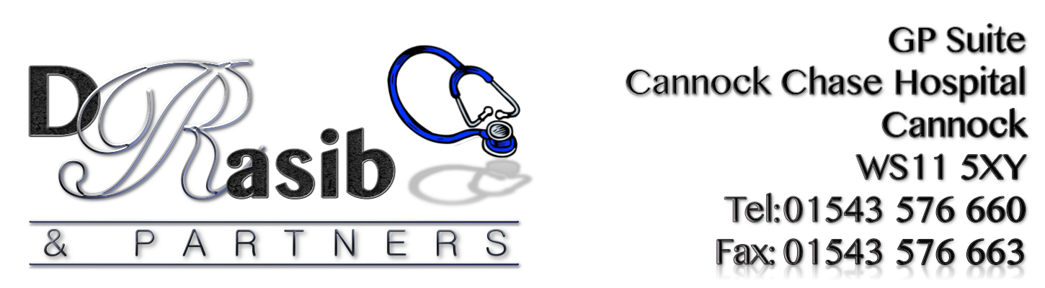

P.P.G. MEETING

Date: Wednesday 4th October 2017
@ 13.00pm
Location: GP Suite Cannock Chase Hospital.

Minutes

1) Persons Present: | Sam Rasib, David Stagg, Margaret Price, Janice Lloyd, Pam Burlingham, Val Cox, Charles McCrone.
2) Apologies: | Betty Chapman, Patrick Pincombe, Sarah Giles, Ann Kirk
3. Minutes of previous meeting held 9th August 2017: | Minutes of previous meeting agreed as correct and passed.
4. Matters Arising: | David introduced our new member Charles McCrone.  David apologized for not having had time to do anything about walking football due to personal commitments. He will be looking into this.
5. Managers Report: | Current patient list size is 5533.  Newsletter:  Winter newsletter is due 1st December – all contributions to be in by 14th November please. Janice suggested earlier planning meeting for next issue. David suggested possible date 8th November - will confirm with everyone.  Clinics:  New service launched at practice - Osteoarthritis clinics with Jenny Ashley.  Mental Wellbeing Clinics:  Mental wellbeing clinics have been introduced and are doing well. They will increase to twice weekly from 24/10/17.  Patient Buddy Scheme:  There needs to be an increase in the awareness of the Patient Buddy Scheme.  Led Walk Group:  Led Walks launching on 5th October and will be weekly, initially Thursdays but may change to Wednesdays once Sam & Val have completed their Walk Leader training on November 2nd.  Sam is trying to get several types of groups in the future, aimed at promoting patient health and fitness.  Patient Streaming:  This was tried for 3weeks but has now been stopped due to: a) Several patients did not want to share their reason for requesting an appointment. b) Staff received verbal abuse. C) The number of complaints received rose.  Care Navigation/Active Signposting:  From 1st November all practices in the Cannock Chase area are to use the commence care navigation. All staff have received appropriate training for this. Patients will need to give information to get them “signposted”. Patients will be provided with information about the people who will deal with signposted patients. Other specialties will be used to provide a multi-skill team to deal with their needs. This should ensure same day treatment.  This information will be added on the surgery waiting room screen to advertise it. Margaret offered to write to Chase Post to get it advertised more and it will also be placed in the newsletter. Patients need to be made aware it is part of the Governments 5 year forward view plan and will eventually be in ALL surgeries. There will be close monitoring of people answering calls to ensure patients are handled in the correct way.  It was suggested that a slip of paper, detailing information about the care navigation could be handed out whilst doing patient surveys, to promote the service further.  PPG members are the voice of the practice, and we need to spread the word that this is trying to get people the help they need, with the correct professional, as quickly as possible.  Safe and Well Visits:  The Practice is working with the Fire Service to provide ‘Safe Well visits’ to patients whom may be vulnerable and would benefit from these. They will check/fit smoke detectors to ensure people are living in a safe environment. Anyone who may have concerns about a patient should contact the practice staff so that they can speak to patient to gain consent in order to make a referral.
6. Group Participation | Patient Surveys:  A list of dates was passed round for people to say when they will come in to the surgery to get patients to complete questionnaires. If anyone not present at the meeting would like to help out, the list of dates available is in reception for you to check when someone is needed and to add your name to.  Noticeboard:  A list was passed round for members to volunteer for noticeboard duties. Please let Pam or Janice know if you can do any.  A copy of the terms of reference and membership was handed out to those present. There are still 2 positions vacant a) A newsletter secretary – to collect and forward information to Sam /David for inclusion in newsletters. b) A survey/questionnaire administrator.  A copy of Cannock Chase District Patient Group Bullet Point Action List from their September meeting was handed out to members present. Sam stated that more communication between CCQ and PPG’s needed, but not very optimistic that things will change.  NIHR _ Ntl Institute for Health Research are looking for lay representatives (patients). Anyone interested in a 3yr office with honorarium and travel expenses speak to David.
7. Health Walk update: | Sam & Val will be attending 1st walk tomorrow with Age UK and will continue with their assistance until they have had their official Lead Walker training. Walks will continue weekly on Thursdays at 11a.m until training has been completed in November. Walk day will probably change to Wednesdays after the training has been completed. Please spread the word – this is a short walk of approx. 30 minutes duration at a very leisurely pace, has an option for a toilet break and optional stop for coffee and a chat on return to base. If anyone wants to join in, just turn up at the surgery before 11a.m.
8.Staff turnover/moral. | Margaret commented on a recent experience whilst sitting in waiting area. She experienced patient’s complaining/not being happy about various things and taking it out on the staff.
9. Any Other Business: | Next newsletter meeting date to be confirmed.

Date of Next Meeting: 13th December @1pm

“Xmas meeting/party” 13th December 2017 at 1 p.m.
This will be a brief meeting with date of next full meeting to be decided followed by Xmas get together.

